**SOFTWARE REQUIREMENTS SPECIFICATION**

**for**

**TEMPLE MANAGEMENT SYSTEM**

***Prepared by***

## Vineetha o nair 700042 vineethaonair@mca.ajce.in

**Project Guide: sona sebastein**

## Date:

**DEPARTMENT OF COMPUTER APPLICATIONS, AJCE**

**CHAPTER - 1**

**INTRODUCTION**

## 1.1 PURPOSE

The purpose of this document is to provide a detailed description of the ‘Temple Management System’. This SRS will give a complete understanding of the ‘Temple Management System’ to be constructed. The main purpose of ‘Temple Management System’ is to reduce the manual operation required to handle salary payments, employee management, leave management, and allow devotees to make online offerings, pooja bookings. Temple Management Package is a highly scalable product for Hindu Temples. It helps temple administrators to assure effective devotee service. Reduce data entries lead to eliminate chances for errors and reduce operator effort.

The objective is to build a software system that is user friendly and accurately generates and stores data. Simple user interface to reduce operation time. In temple management system, we have a system where we can a user who is eager to get the darshan of the temple at the time and want to do the specific task at the venue. As he confirms after doing the necessary payment it will be forwarded to the management of the temple they get the token to clear and they do the same with the arrangements done. User comes up to the temple at a time get the darshans done.

## 1.2 SCOPE

The temple management system is a web based application. There are many religions in the world, everyone has different ways worshipping God, one of them is temples were mainly Hindus believe to worship.  The darshans become very difficult as people maybe wanted to get darshans at their time and have some work or proper management can also be managed. So we come up with a system where users are required to register for the darshans for the given time as they can book the devotional aartis at a particular time. They require to fill the details about it and timing and then they will get the token after giving a nominal amount of payment. The arrangements will be done by the temple management to do the required worship apart from the queue. They need to show the token to get the special entry. Finally, they will get the darshans without any hesitation and without difficulty at their time.

The system is made of the combination of modules which work with collaboration with each other and make it beneficial to accomplish the main aim of the system.

Major functional modules:

* Registration and login
* Darshanam booking
* Auditorium booking
* Vazhipadu booking
* Staff management
* Students management
* Manage Festival details

# 1.3 DEFINITIONS, ACRONYMS, AND ABBREVIATIONS

PHP-Personal Home Page

JS-Java Script

HTML-Hypertext Markup Language

SQL-Structured Query Language

# 1.4 REFERENCES

* [www.w3schools.com](http://www.w3schools.com/)

# 1.5 OVERVIEW

**EXISTING SYSTEM**

* There is no existing website for this organization.
* Information about this system is recorded manually.
* All the data stored in the paper or a register.
* When the people wants to see the information about this temple like opening-closing time, arti time, program date, and other facilities then they must be go to this temple.

**DRAWBACKS OF EXISTING SYSTEM**

* It is not an automatic system.
* This system is time consuming.
* Searching facility is not easy in current system.
* It takes too much to data storage.
* Data cannot be maintain for a long time.
* When the people comes to visit this temple, then he face some problems like they do make darshanam at correct time, and waste a lot of time of taking darshanam.

**PROPOSED SYSTEM**

* A new system provides the feature like easy to understand, view information, etc.
* All the data stored in the computer.
* When this organization made the function, then all the records are stored in this site.
* User can easily see all the types of the information of this temple. The main features include:
* Registration and login
* Darshanam booking
* Auditorium booking
* Vazhipadu booking
* Staff management
* Students management
* Manage Festival details

**ADVANTAGES OF PROPOSED SYSTEM**

* Less time consuming.
* User can easily work with the system.
* The information can be updates easily.
* Student’s details can be given online.
* Provide online darshanam booking, auditorium booking, and vazhipadu booking facility.

**CHAPTER - 2**

**OVERALL DESCRIPTION**

# 2.1 PRODUCT PERSPECTIVE:

The Temple Management System is an independent product that automates all the tasks that are carried out in a temple .First in this web site it is necessary to see that only admin is able to change the system’s data. So this system admin id and password is used and without knowledge of admin id and password no one can able to enter in the system data. So the data become secure. It maintains all the details related to the various devotees, and also about the students who are study in the mathapadashalla. The temple management system keeps all the details of the persons can book darshanam, vazhipadu and provide an online auditorium booking facility then online payment facility has been provided. After completing these process generate a receipt. Admin can add the details of the upcoming festivals and users can view the festival details. It keeps information about the employees and the payment of salary. The details of employees are stored and they can apply for leave.

# 2.2 PRODUCT FUNCTIONS/FEATURES:

The objective is to build a software system that is user friendly and accurately generates and stores data that automates all the tasks in a temple. The software system should be convenient for its users. The aim of proposed system is to develop a system with improved facilities.

The major functional modules are:

* **Registration and login**

The Temple Management System allows the users registration and login. The ordinary users can directly register their details and can login. The employees are registered by the manager or admin using their official details. The username and password are send to the employees thorough E-mail or SMS.

* **Darshanam management**

User make request through booking at a particular time and after conforming request they will prompt to payment. Give an option to pay through in the form of debit card after payment print the receipt.

* **Vazhipadu management**

User can book vazhipadu online and provide a payment facility. After payment print the receipt. So user can save the time of the users.

* **Leave Management**

The employees can apply for leave through this system. The admin and manger can view the leave applications and can approve or reject it. The leaves taken will affect the salary of the employee. The salary will be deducted based on number of days.

* **Staff Management**

After the employees are registered by the concerned authority, the username and password are send to them. Using this username and password they can login to the system. The employees can complete their profile. The employees can view their attendance percentage of each month.

* **Auditorium management**

User can book the auditorium by using internet and also pay through internet then print the receipt.

* **Festival management**

Admin can add upcoming festivals and users can view the details of the festivals.

* **Student management**

Admin can add student’s details. Edit or delete students and can view their profile..

# 2.3 USER CHARACTERISTICS:

The Temple Management System has 2 users.

1. **Admin Module:** The admin can access the entire system functionalities.
2. **Devotee Module:** Theusers can registration and login. The ordinary users can directly register their details and can login. The admin can view the details of the devotees and can approve or reject the request and also make receipt. Devotees of Temple can be managed with the help of this module as, Entry of new devotee with their detail profile & contact Information can be done through this module. Provide online booking facility. Users can view upcoming festival details.

# 2.4 OPERATING ENVIRONMENT

**Hardware Specification**

Processor : Pentium IV/AMD Dual core or above

RAM : 2 GB and above

Hard disk : 500 GB and above

**Software Specification**

Front End : PHP (Codeigniter)

Backend : MySQL

Client on PC : Windows 7 and above.

Technologies used : JS, HTML5, AJAX, J Query

#### 2.5 USER DOCUMENTATION

The ‘Temple Management System’ will provide a user’s manual for the administrator. To assist the user in understanding the product better and to assist them in better utilization of the product and its features, we will be providing an interactive user interface (in DOC format).

**2.6 ASSUMPTION AND DEPENDENCY**

We are assuming that the users will not use our product to download copyright. Also, we expect that the users not only use the software to view resources, they will also be updating details and resources for being viewed by other users. We also assume that product users will not do malicious activities on the software.

**CHAPTER - 3**

**SPECIFIC REQUIREMENTS**

## 3.1 EXTERNAL INTERFACE REQUIREMENTS

The “**Temple Management System**” will use the following input/output devices for a personal computer. The external interfaces are:

* Keyboard
* Mouse
* Monitor

**3.1.1 User Interfaces**

|  |  |
| --- | --- |
| **FORMS** | **DESCRIPTION** |
| Home | Log into the site as an Administrator, Staff, or Devotees. |
| Registration | Administrator, Staff, and Devotees can register to get access. |
| Staff Management | Save employee information, view and update them |
| Darshanam Management | User make request through booking at a particular time and after conforming request they will prompt to payment. |
| Vazhipadu Management | User can book vazhipadu online and provide a payment facility. After payment generate receipt. |
| Auditorium Management | User can book the auditorium by using internet and also pay through internet then print the receipt |
| Festival Management | Admin can add upcoming festivals and users can view the details of the festivals. |
| Student Management | Enter student’s details. Edit or delete students and can view their profile. |

**3.1.2 Hardware Interfaces/\***

**Temple Management System** is a web based application.

**3.1.3 Software Interfaces**

Database Server: MySQL

Development End: PHP

Client on PC: Any Browser

**3.2 FUNCTIONAL REQUIREMENTS**

The functional requirements are those requirements which are necessary to the eye of the user and the client. Here we try to make the module possible to accomplish the need of the desired function. Few of its functional requirements are as follows- Auditorium Management, Darshanam Management, Vazhipadu management, Leave Management, Festival Management, and Staff Management.

**3.2.1** **Registration**

* + - 1. Introduction

The users can register in to the system. There is a staff registration and ordinary user registration. The staff are registered by the admin. The ordinary users can directly register their details.

* + - 1. Inputs

In this module, for staff registration, the staff information like Staff id, Name, designation, address, contact details, bank information, Image etc. are entered into the database. Ordinary user registration, address, birth star, name and password are given.

* + - 1. Processing

After staff registration, the username and password are send to them by mail or SMS. Then staff can login to the site and can update personal information and password.

* + - 1. Outputs

When registration is completed, a success message is displayed in case of employee. The ordinary users are directed to their home page.

* + - 1. Error Handling

During the registration process, all the inputs are validated and if there is any error, it is displayed. If a username is already in use, it also displayed.

**3.2.2 Darshanam Management**

3.2.2.1 Introduction

This module allow to manage darshanam at the temple at right time.

3.2.2.2 Inputs

Booking id, time date, username, password

3.2.2.3 Processing

Provide on line booking facility and devoees can get darshanam at right time.

3.2.2.4 Output view

When booking is completed, a success message is displayed on the screen.

3.2.2.5 Error Handling

During the booking process, all the inputs are validated and if there is any error, it is displayed.

**3.2.3Vazhipadu Management**

3.2.3.1 Introduction

This module allow to manage vazhipadu at the temple on particular days.

3.2.3.2 Inputs

Vazhipadu id, vazhipaduname, cost, booking id.

3.2.3.3 Processing

After registration devotees can book online vazhipadu and then payment can done through online.

3.2.3.4 Output view

When booking is completed, a success message is displayed on the screen.

3.2.3.5 Error Handling

During the booking process, all the inputs are validated and if there is any error, it is displayed.

**3.2.4 Auditorium Management**

3.2.4.1 Introduction

This module allow to manage auditorium details at the temple and users can book the auditorium through online.

3.2.4.2 Inputs

Auditorium id, seats, date, rate, booking id.

3.2.4.3 Processing

User can book the auditorium by using internet and also pay through internet then print the receipt

3.2.4.3 Output view

When booking is completed, a success message is displayed on the screen.

3.2.3.5 Error Handling

During the booking process, all the inputs are validated and if there is any error, it is displayed.

**3.2.5 Festival Management**

3.2.5.1 Introduction

User can view the details of the festival.admin can enter the details of the festivals.

3.2.5.2 Inputs

Festival id, name, time, date.

3.2.5.3 Processing

Admin can add upcoming festivals and users can view the details of the festivals.

3.2.5.4 Output view

Users can view the details.

3.2.5.5 Error Handling

* + 1. **Staff Management**

3.2.6.1 Introduction

This module allows to view employee details and update them if needed.

3.2.6.2 Inputs

Name, address, contact information, profile picture, password

3.2.6.3Processing

After staff registration, the username and password are send to them by mail or sms. Then staff can login to the site and can update personal information and password.

3.2.2.4 Outputs view profiles

3.2.2.5 Error Handling

During the registration process, all the inputs are validated and if there is any error, it is displayed. If a username is already in use, it also displayed.

##### 3.2.1 INPUT FORMS

Home Page

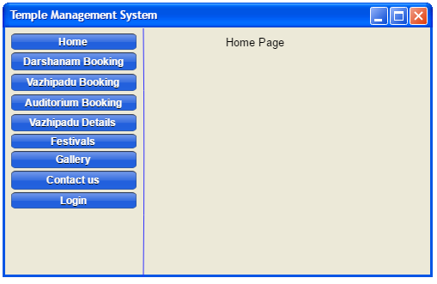

Devotees Registration

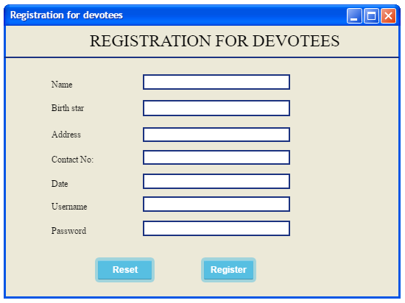

User Login

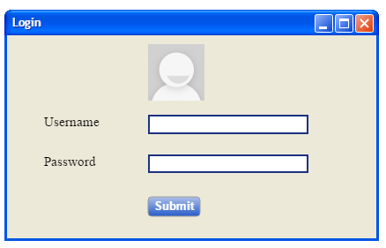

Vazhipadu Details

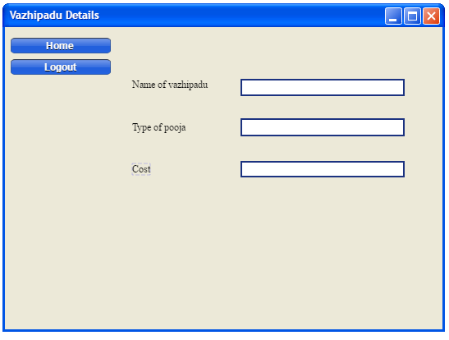

View Festival Details

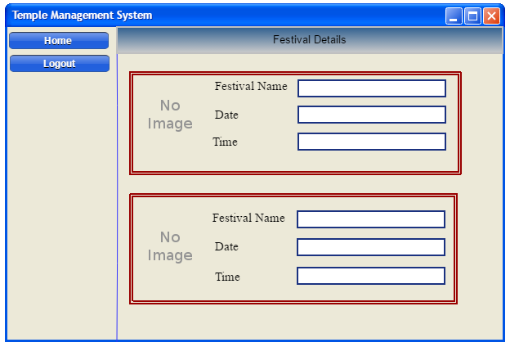

Admin

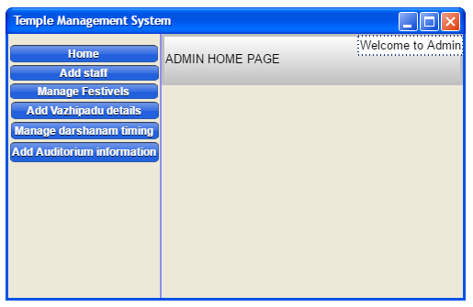

**3.2.2 OUTPUT FORMS**

Vazhipadu Booking

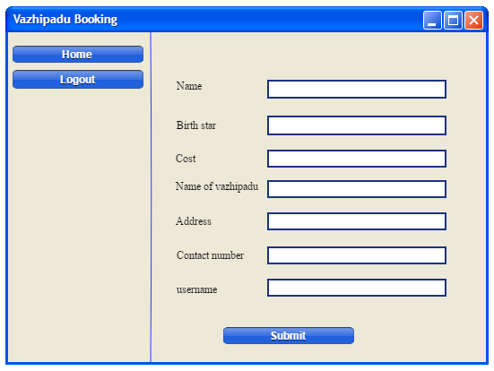

## 3.7 Other Documents

##### 3.7.1 DATA FLOW DIAGRAM

ZEROTH LEVEL DFD FOR TEMPLE MANAGEMENT SYSTEM

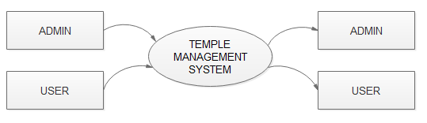

FIRST LEVEL DFD FOR ADMIN

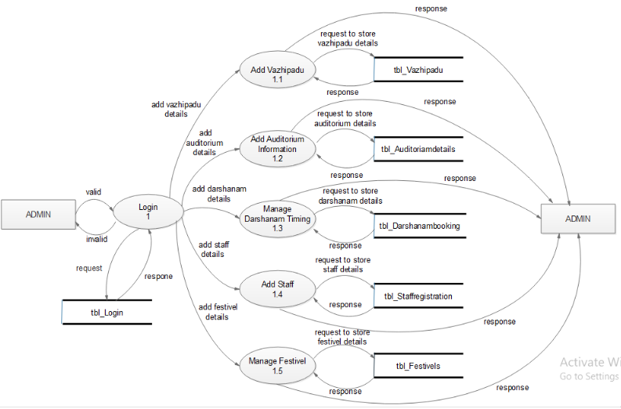

FIRST LEVEL DFD FOR USER

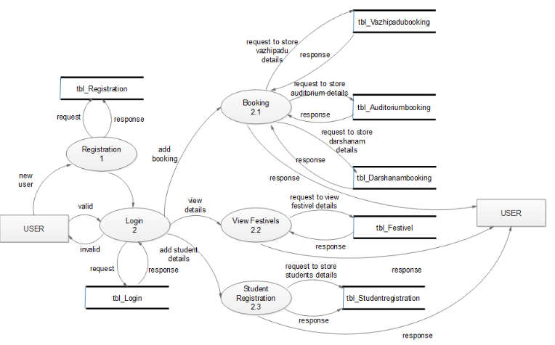

SECOND LEVEL DFD FOR USER

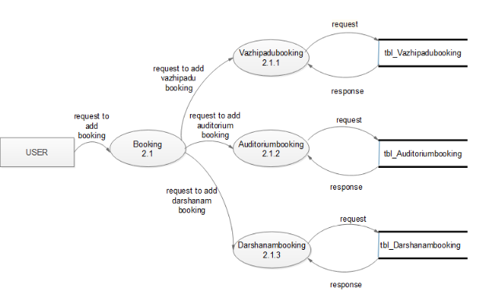

### 1.7.3 TABLE DESIGN

**Table 1**: tbl_Login

Primary key: lid

|  |  |  |  |
| --- | --- | --- | --- |
| FIELD NAME | DATA TYPE | SIZE | DESCRIPTION |
| lid | varchar | 10 | Primary key |
| username | Varchar | 20 | Username of user |
| Passwd | Varchar | 30 | Password of user |
| Type | varchar | 4 | Type of login |
| Status | int | 2 | status |

**Table 2**:

**Table 2:** tbl_Registration

Primary key: regid

Forgign key: lid (tbl_Login)

|  |  |  |  |
| --- | --- | --- | --- |
| FIELD NAME | DATA TYPE | SIZE | DESCRIPTION |
| Regid | varchar | 10 | Primary key |
| Lid | varchar | 10 | Foreign key |
| Name | Varchar | 20 | Name of user |
| birthstar | varchar | 15 | Birth star of user |
| address | Varchar | 50 | Address of user |
| Phone | int | 10 | Phone number of user |
| Date | date |  | Current date |
| Email | varchar | 30 | Email id |
| Status | Varchar | 3 | status |

**Table 3**: tbl_Vazhipadu

Primary key: vazid

|  |  |  |  |
| --- | --- | --- | --- |
| FIELD NAME | DATA TYPE | SIZE | DESCRIPTION |
| Vazid | varchar | 10 | Primary key |
| Type | Varchar | 30 | Type of vazhipadu |
| Vname | Varchar | 20 | Name of pooja |
| Cost | Int | 25 | Cost of vazhipadu |
| Status | Varchar | 3 | status |

**Table 4**: tbl_Vazhipadubooking

Primary key: bookid

Forign key: vazid (tbl_Vazhipadu),

regid (tbl_Registration)

|  |  |  |  |
| --- | --- | --- | --- |
| FIELD NAME | DATA TYPE | SIZE | DESCRIPTION |
| Bookid | varchar | 10 | Primary key |
| Vazid | varchar | 10 | Foreign key |
| Regid | varchar | 10 | Foreign key |
| Status | Varchar | 3 | status |

**Table Table Table Table 5**:tbl_Bank

Primary key: cardno

|  |  |  |  |
| --- | --- | --- | --- |
| FIELD NAME | DATA TYPE | SIZE | DESCRIPTION |
| cardno | varchar | 30 | Primary key |
| custname | varchar | 20 | Customer name |
| Cvv | varchar | 5 | Cvv number |
| username | Varchar | 20 | Username of user |
| balance | int | 30 | Balance of user |

**Table 6**:tbl_Auditoriumdetails

Primary key: audid

|  |  |  |  |
| --- | --- | --- | --- |
| FIELD NAME | DATA TYPE | SIZE | DESCRIPTION |
| Audid | varchar | 10 | Primary key |
| Seats | int | 50 | Number of seats |
| Rate | int | 50 | Rate of auditorium |

**Table 7:** tbl_Auditoriumbooking

Primary key: bkid

Foreign key: audid (tbl_Auditoriumdetails)

regid (tbl_Registration)

|  |  |  |  |
| --- | --- | --- | --- |
| FIELD NAME | DATA TYPE | SIZE | DESCRIPTION |
| Bkid | varchar | 10 | Primary key |
| Audid | varchar | 10 | Foreign key |
| Regid | Varchar | 10 | Foreign key |
| Days | date |  | Number of days |

**Table 8:** tbl_Darshanambooking

Primary key: dbkid

Foreign key: regid (tbl_Registration)

|  |  |  |  |
| --- | --- | --- | --- |
| FIELD NAME | DATA TYPE | SIZE | DESCRIPTION |
| dbkid | varchar | 10 | Primary key |
| regid | varchar | 10 | Foreign key |
| time | varchar | 20 | Darshanam time |
| date | date |  | Darshanam date |

**Table 9:** tbl_Staffregistration

Primary key: staffid

Foreign key: lid (tbl_Login)

|  |  |  |  |
| --- | --- | --- | --- |
| FIELD NAME | DATA TYPE | SIZE | DESCRIPTION |
| staffid | varchar | 10 | Primary key |
| lid | varchar | 10 | Foreign key |
| stname | varchar | 20 | Staff name |
| address | varchar | 50 | Address of staff |
| phone | int | 10 | Phone number of staff |
| salary | varchar | 30 | Salary of staff |
| img | varchar | 20 | Image of staff |
| status | varchar | 3 | status |

**Table 10:** tbl_Designation

Primary key: desigid

Foreign key: staffid (tbl_Staffregistration)

|  |  |  |  |
| --- | --- | --- | --- |
| FIELD NAME | DATA TYPE | SIZE | DESCRIPTION |
| desigid | varchar | 10 | Primary key |
| staffid | varchar | 10 | Foreign key |
| designame | varchar | 30 | Designation name |
| status | varchar | 3 | status |

**Table 11:** tbl_Festivel

Primary key: festid

|  |  |  |  |
| --- | --- | --- | --- |
| FIELD NAME | DATA TYPE | SIZE | DESCRIPTION |
| festid | varchar | 10 | Primary key |
| festname | Varchar | 20 | Festivel name |
| date | date |  | Date of festivel |
| time | varchar | 10 | Time of festivel |
| status | varchar | 3 | status |

**Table 12:** tbl_Studentregistration

Primary key: studid

Foreign key: lid (tbl_Login)

|  |  |  |  |
| --- | --- | --- | --- |
| FIELD NAME | DATA TYPE | SIZE | DESCRIPTION |
| studid | varchar | 10 | Primary key |
| lid | varchar | 10 | Foreign key |
| studname | varchar | 20 | Student name |
| age | int | 20 | Age of student |
| address | varchar | 50 | Address of student |
| phone | int | 10 | Phone number of student |
| img | varchar | 20 | Image of student |
| status | varchar | 3 | status |